**Using IG Sample Templates**

Contents

Introduction 2

Templates 2

Installation 2

Instructions 3

Section A – If neither SL or WPF samples project exists 4

Section B – If SL samples project already exists and WPF project needs to be created. 6

Section C – If WPF samples project already exists and SL project needs to be created. 9

Section D – If a new sample needs to be added to the existing IG samples project 9

History 11

# Introduction

This document explains how to use IG Samples Templates to create IG sample projects and IG sample pages for SL/WPF Sample Browsers.

# Templates

The following table lists all available templates for IG samples and their purpose.

|  |  |  |
| --- | --- | --- |
| Template Name | Template Type | Description |
| IG Sample Project .WPF | Project Template | Creates a new IG samples project (WPF class library) for WPF Sample Browser |
| IG Sample Project .SL | Project Template | Creates a new IG samples project (SL application) for SL Sample Browser |
| IG Sample Page | Item Template | Creates a new IG Sample Page for XAML Samples Browser. This page should be shared between SL and WPF Samples Browsers. |

# Installation

In order to install IG Samples Templates, open the following directory on your local drive and copy appropriate zip files that contain the IG Samples Templates:

|  |  |
| --- | --- |
| Template Type | Install Directory |
| Project Template | C:\Users\<USER_NAME>\Documents\Visual Studio 2010\Templates\ProjectTemplates |
| Item Template | C:\Users\<USER_NAME>\Documents\Visual Studio 2010\Templates\ItemTemplates |

# Instructions

This section provides instructions on how to use IG Samples Templates to create new IG samples. They must be followed as they are listed in order to preserve the structure of the XAML Sample Browser and enable code sharing between SL/WPF Sample Browsers.

Note: These instructions could be simplified if IG Samples Projects Templates had custom wizards for creating project files in destination folders instead of project subfolders.

1. Open one of the following VS solutions:

* Infragistics.Samples.SL.sln
* Infragistics.Samples.WPF.sln

1. In Source Control Explorer, navigate to the location of the XAML Sample Browsers:

$/NetAdvantage/DEV/XAML/2012.1/Samples/XAML

1. Check if a IG samples project already exists in TFS for a IG component/control:

## Section A – If neither SL or WPF samples project exists

1. Select **File – Add – New Project…** menu item
2. Under **Installed Templates** tree node, select appropriate IG Samples Project depending on the opened Sample Browser:

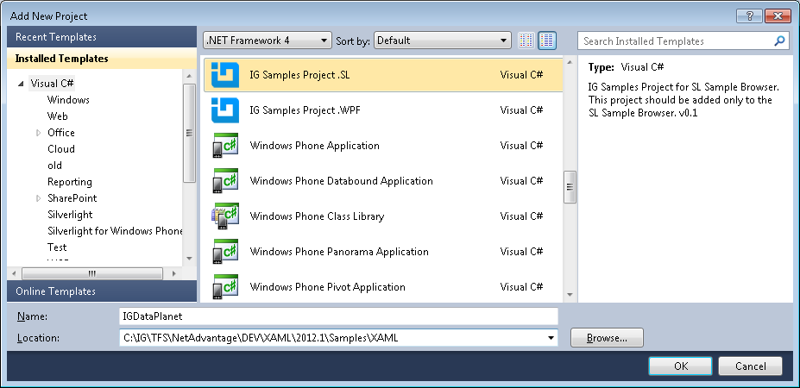

1. Type a name for the new project using the following naming convention: **IG<ComponentName>**

Note: Do not add either “**.SL**” or “**.WPF**” to the project name at this point (see step 6)

|  |  |
| --- | --- |
| IG Component Name | IG Samples Project Name |
| XamDataChart | IGDataChart |
| Resource Washer | IGResourceWasher |

1. Make sure that the project location points to this folder:

…\NetAdvantage\DEV\XAML\2012.1\Samples\XAML

1. Click the **OK** button to generate a new IG samples project in opened VS solution.
2. In Solution Explorer, located newly created project and append “**.SL**” or “**.WPF**” to its name.

Note: Do not change assembly name or default namespace.

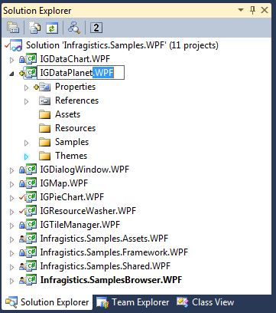

1. Save and check-in the VS solution to TFS when done creating IG samples projects.

## Section B – If SL samples project already exists and WPF project needs to be created.

1. Select **File – Add – New Project…** menu item
2. Under **Installed Templates** tree node, select **IG Samples Project for WPF Sample Browser**:

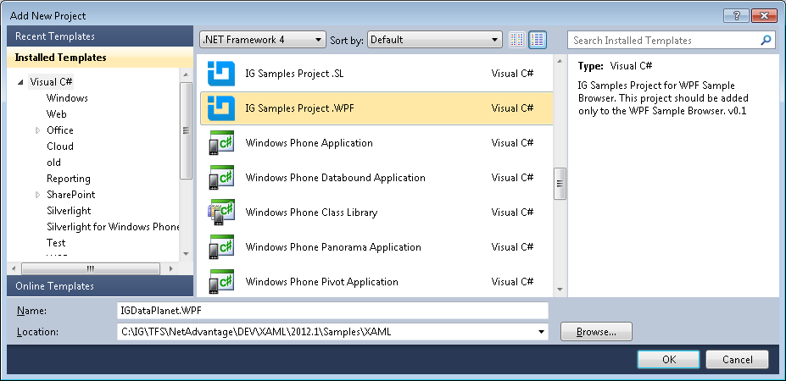

1. Type a name for the new project using the following naming convention: **IG<ComponentName>.WPF**

|  |  |
| --- | --- |
| IG Component Name | IG Samples Project Name |
| XamDataChart | IGDataChart.WPF |
| Resource Washer | IGResourceWasher.WPF |

1. Open Properties page of the newly created project.
2. Remove “**.WPF**” from the Assembly Name and Default Namespace fields:

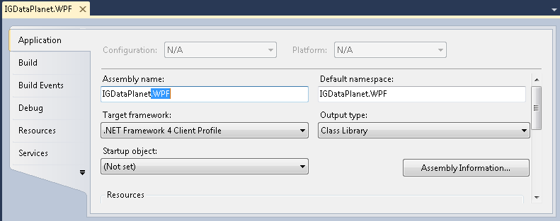

1. Save the project and select **Open Folder in Windows Explorer** from right-click menu:
2. Copy the **\*.WPF.csproj** project file.
3. Navigate up one level, open **IG<ComponentName>** folder, and paste the project file

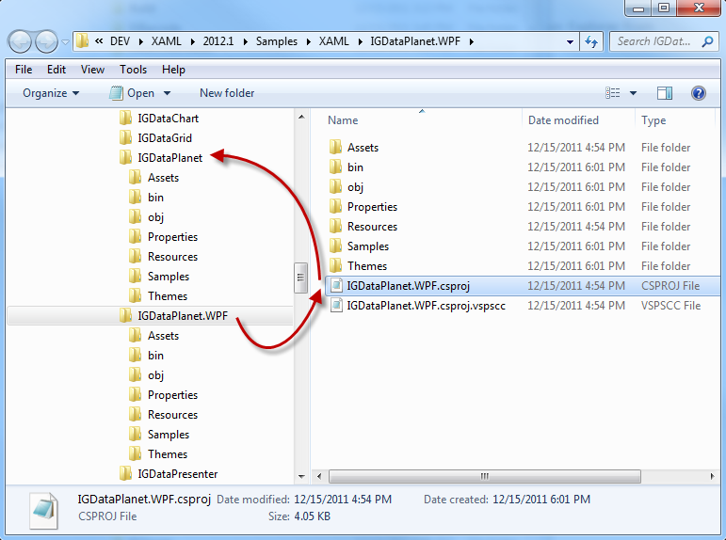

1. In Solution Explorer, remove the **IG<ComponentName>.WPF** project.
2. Undo pending changes on **IG<ComponentName>.WPF** folder in TFS.
3. Select **File – Add – Existing Project…**
4. Navigate to the copied project in the **IG<ComponentName>** folder: **IG<ComponentName>.WPF.csproj**
5. Click on the **Open** button to load the project to VS solution.
6. In Source Control Explorer, add the following two files:

* **IG<ComponentName>.WPF.csproj**
* **IG<ComponentName>.WPF.csproj.vsoscc**

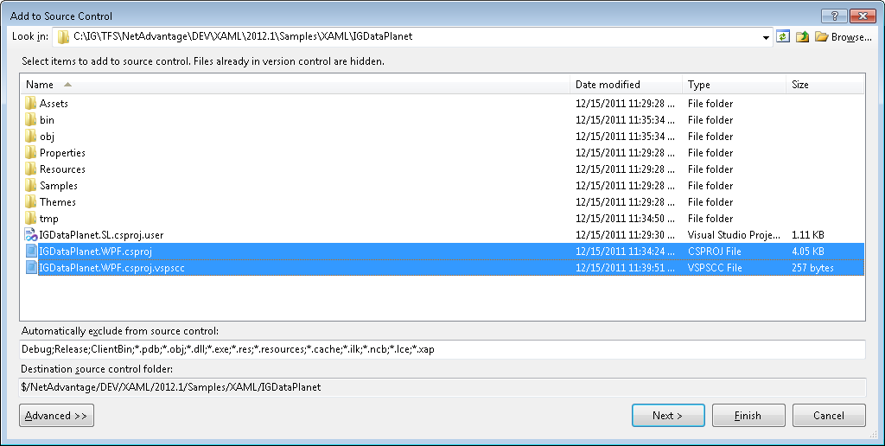

1. Save and check-in the VS solution.

## Section C – If WPF samples project already exists and SL project needs to be created.

1. Repeat all steps from section B with substituting “.WPF” with “.SL”.

## Section D – If a new sample needs to be added to the existing IG samples project

This section should be followed when adding samples that can be shared between SL/WPF Sample Browsers.

1. In Solution Explorer, navigate to a location where a new sample should be located:

For example: IGDataChart (project) – Samples (folder) – Data (folder)

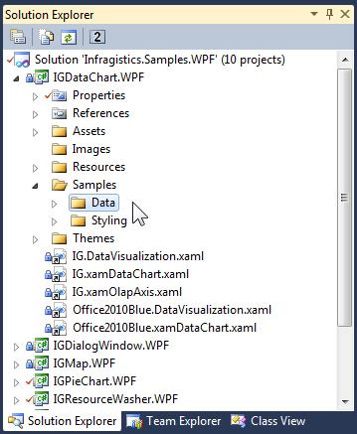

1. Select **Add – New Item…** from the right-click menu.
2. Select IG Sample item under Installed Templates – Visual C# tree node:

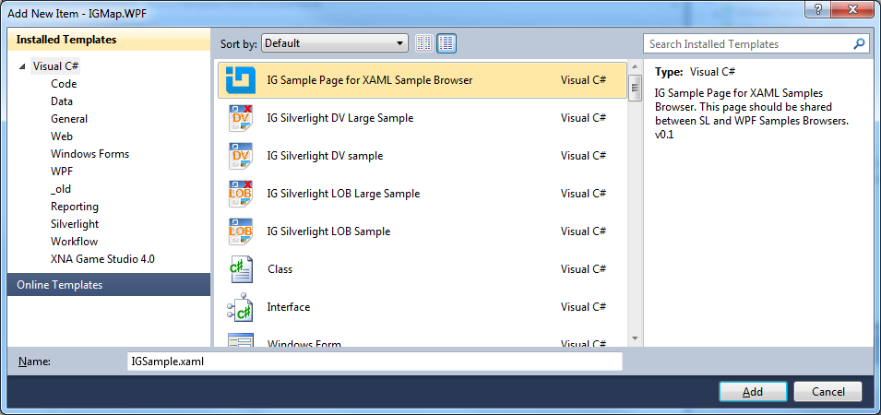

1. Type a name for the sample and click on the Add button.
2. Implement the sample and check it in.

# History

|  |  |
| --- | --- |
| Version | Changes |
| 1.0 | MT- Initial Draft |
|  |  |